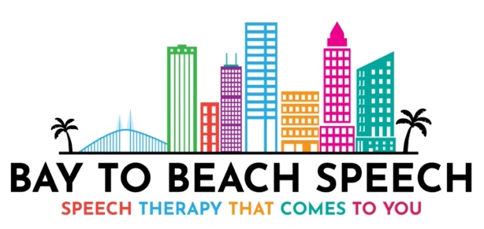

Parent Guide: How to file for Out-Of-Network Benefits

Dear Parent,

I hope this document will assist, as you contact your insurance company to determine their process for filing out-of-network benefits. It should also help you determine whether you have Speech Therapy benefits as part of your policy, and how to submit a claim for possible reimbursement for the services you’ve already paid for.

- Call the member services phone number on the back of your insurance card.
- Tell the Customer Service Representative you would like information about your coverage for Speech Therapy benefits with an Out-Of-Network provider.
- Document your conversation:

- Name of Customer Service Representative
- Date of call
- Time of call

- Have the following information ready & available for the call in the event they need it:

Insured’s Name:
Patient’s name:
DOB:
Insurance Member ID:
Policy/Group Number:
Provider: Bay to Beach Speech- Lindsay Kallam M.S. CCC-SLP
State License: SA 17327
ASHA Certification: 14154488
NPI Number: 1720635618

- Ask these questions if relevant, when speaking to the Customer Service Representative:

What is my coverage for Speech Therapy benefits?
Do I need pre-authorization for Speech Therapy? If so, how do I obtain it?
Can I submit a Superbill?
What is the process for filing a claim after I have a Superbill for services?
What additional forms do I need to submit when filing my claim?
Where can I find the forms on your website? Can you email me a copy?
Can I file my claim online or do I need to mail/fax it to you?
Do I need to file my claim within a certain amount of time after the date of service?
How long does it take to process my claim?
Can I appeal if a claim is denied?

Your insurance company MAY want to know which charge codes and diagnosis codes will be used. Until completing an evaluation, I’m unable to provide these.

During our initial phone consultation, I may let you know which of the following codes might be appropriate; however, they will be my best estimate based on the information you provide, but they may change after the formal evaluation.

Speech Therapy CPT Codes:

92507- Treatment of speech, language, voice, communication and/or auditory processing disorder; individual

92508- Treatment of speech, language, voice, communication and/or auditory processing disorder; group

92526- Treatment of swallowing dysfunction and/or oral function for feeding

92522- Evaluation of speech sound production (articulation, phonological process, apraxia, dysarthria)

92523- Evaluation of speech sound production (articulation, phonological process, apraxia, dysarthria) WITH evaluation of language comprehension and expression (receptive and expressive language)

92521- Evaluation of speech fluency (stuttering, cluttering)

92610- Evaluation of oral and pharyngeal swallowing function

Speech Therapy Diagnosis (ICD-10) Codes:

F80.0- Phonological Disorder (Articulation Therapy)

F80.2- Mixed Receptive-Expressive Language Disorder

F80.81- Childhood Onset Fluency Disorder (Stuttering)

F80.4- Speech and Language Development Delay due to Hearing Loss

R48.2- Apraxia

R63.3- Feeding Difficulties

